The file format for running this program is as follows:

I highly recommend drawing the circuit you wish to simulate.

The format of the circuit file must have as the first value on each line, the type of gate or intersection to simulate followed by labels for wires that are inputs and outputs. A generic example would be

AND Input1 Input2 Output1

Make sure to get the correct wires as the program does not have much error handling within.

|  |  |
| --- | --- |
| List of generic lines |  |
| AND | AND input1 input2 output1 |
| OR | OR input1 input2 input3 |
| NOT | NOT input1 output1 |
| NAND | NAND input1 input2 output1 |
| NOR | NOR input1 input2 output1 |
| XOR | XOR input1 input2 outpu1 |
| INTERSECT | INTERSECT input1 output1 output2 |

Here is an example of a full adder

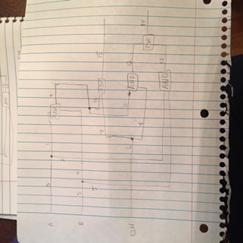

INTERSECT 0 1 2

INTERSECT 3 4 5

INTERSECT 6 7 8

XOR 1 4 9

INTERSECT 9 10 11

AND 11 8 12

XOR 10 7 15

AND 2 5 13

OR 12 13 14